|  |
| --- |
| HM73 |
| The Labyrinth |
| **Documentation** |
| Version 1  All work Copyright © 2012 by XX Games.  All rights reserved. |
| **By: Syeda Mehreen** |
|  |

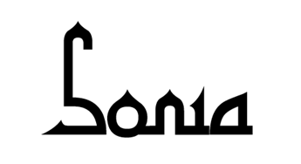

|  |
| --- |
| May 29th 2015 |

Table of Contents

Version History 3

Game Overview 4

Game Play Mechanics 4

Controls 4

Saving and Loading 4

Interface Sketch 4

Menu and Screen Descriptions 5

Game World 6

Levels 6

Game Progression 8

Characters 8

Non-player Characters 8

Enemies 8

Items 8

Cheat Codes 8

Design Notes 8

Future Features 9

References 9

# Version History

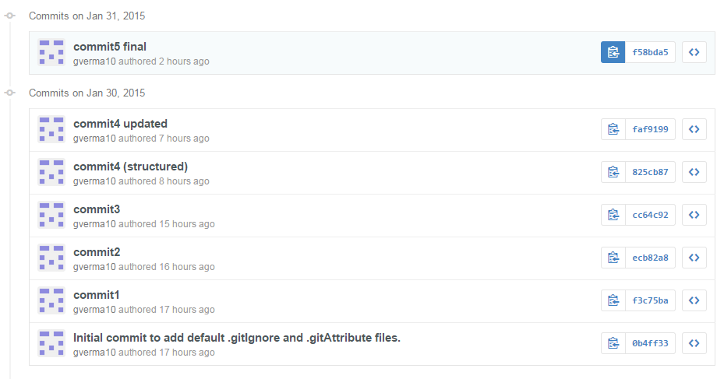

# Game Overview

*This is a game about Sarah who finds herself in labyrinth designed by the goblin king, who has kidnapped Sarah’s brother. To find her way to the castle through that maze she needs to make many difficult decisions.*

# Game Play Mechanics

*The game will move on the selections made by the player. At each next level she cross towards her brother, Sarah has to face a dilemma of choosing the correct path which will lead her to the rescue her brother ‘Toby’.*

# Controls

*The only control that could be used in this game is the mouse. The user can select the available options through the click of the mouse.*

# Saving and Loading

*No such feature as saving and loading has been added so far, but could be implemented in the upcoming versions.*

# Interface Sketch

*The game interface will give the storyline of the game as the player moves ahead with his all intelligence.*

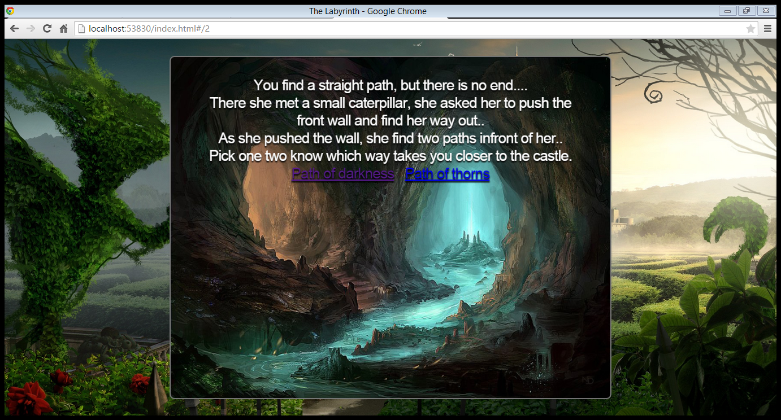

# Menu and Screen Descriptions

*The game have a menu which gives the user a little plot about the game before starting it.*

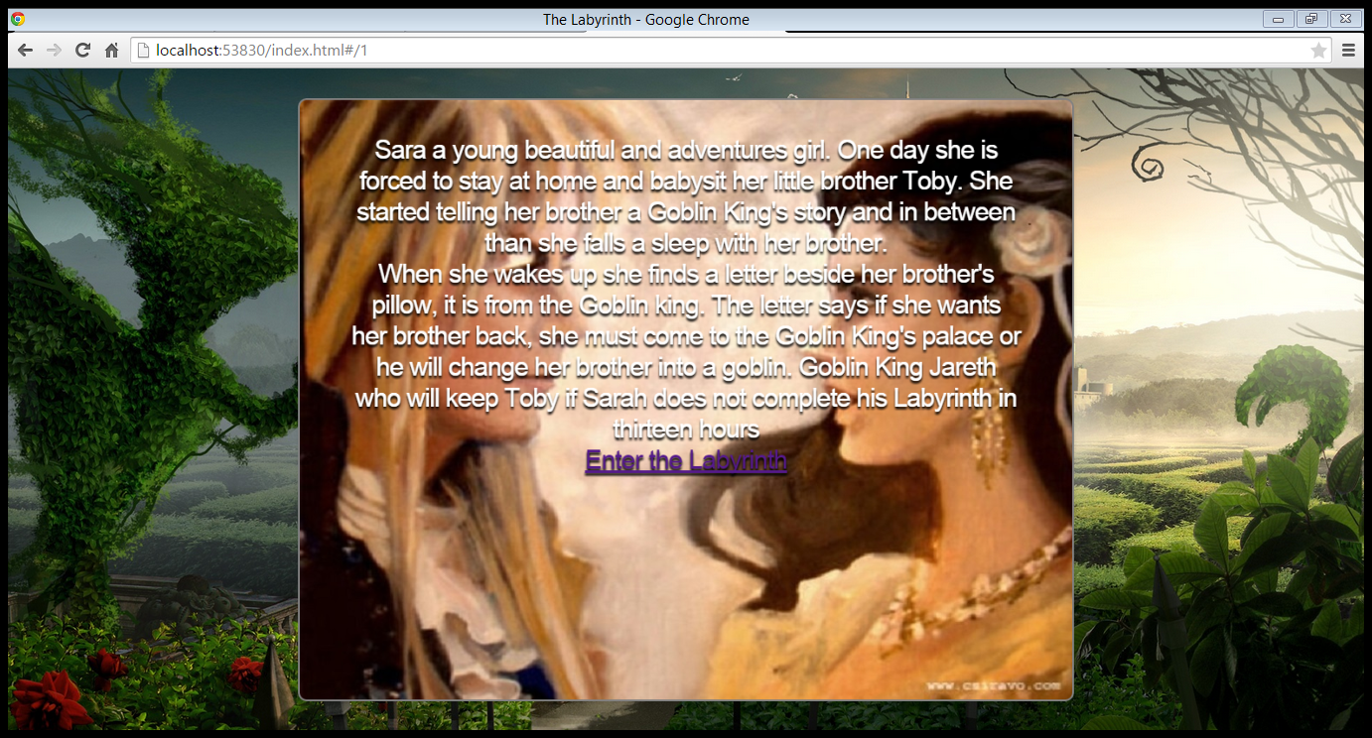

# Game World

*The game is based on the movie ‘The Labyrinth’ (1986). The game has an imaginary world full of suspicious creatures like never seen before.*

# Levels

*Basically looking towards the plot of the game it has been divided into three levels, on each level of the game the player is provided with the two options which may or may not lead to the victory.*

**

*The game begins with the plot and let the user understand what he is getting into.*

*NODE 1: at this node the player decided to enter the labyrinth, as she proceeds further, she gets two paths. The two paths are Path of darkness and the Path of thorns.*

*NODE 2:* *at this node the player is already in the maze and have chosen to follow the path of darkness.* *Where further player will get option to go for the left knocker door or the right knocker door.*

*NODE 3: at this node the player have chosen to follow the path of thorns. Where further player will get option to choose the path to the forest or the path of the Wiseman.*

*NODE 4:* *at this node the player the player meets the left knocker door. On solving whose riddle she gets two more paths to choose from.*

*NODE 5: at this node the player the player meets the right knocker door. On solving whose riddle she gets two more paths to choose from.*

*NODE 6: at this node the player had chosen to enter the forest then given two options to choose from.*

*NODE 7: at this node the player get a chance to seek help from the Wiseman. In order to rescue her brother from the goblin king, she needs to get into the castle. To get inside the castle the player is given two options to choose from.*

*OUTCOME 1: You decide to enter into the black forest, where you get lost and you fail.*

*OUTCOME 2: You decide to take the vacuous door, which ended her in more confusion and you fail.*

*OUTCOME 3: You decide to take the trap door which lead to the trap in which she gets trapped and you fail.*

*OUTCOME 4: You decide to continue your journey and she take the way to the bog of eternal stench and you fail.*

*OUTCOME 5: You decided to walk along the path an meets the junk lady which creates the illusion and stops her from reaching the castle and you fail.*

*OUTCOME 6: You decided to seek some help from the guards at the door which could tell her the correct path, but they didn’t and you fail.*

*OUTCOME 7: You decided to take help from the Wiseman, but as the goblin king leans about it he vanishes the Wiseman from the forest and you fail.*

*OUTCOME 8: You decided to get to the last door and you found the right path into the castle where Sarah found her brother and you succeed.*

# Game Progression

*The game progresses level by level, which depends upon the selections made by the player.*

# Characters

*There is no physical character in the game but as its role play game, the player is the playing as ‘Sarah’, the main character of the game.*

# Non-player Characters

*The non-playing character in this game is Sarah’s Brother ‘Toby’, whom she has to rescue from the goblin king.*

# Enemies

*The princes has many enemies like fireys, junk lady, creatures. The main conspirator is considered to be the goblin king as he was the one who kidnapped Sarah’s brother ‘Toby’.*

# Items

*No such concept has been implemented in this version but could be considered in the forthcoming versions.*

# Cheat Codes

*No cheat codes are applicable for this game so far as the difficulty level is not much. But could be considered in the forthcoming versions.*

# Design Notes

*The designing of the game is kept simple to make it more user friendly. And the images used are from the various external sources.*

# Future Features

*In future the new features could be introduces like 3D characters, virtual weapons, sound effects, graphical rendering, etc.*

# References

*The images used in this are taken from various sources*

* *Google images*
* *Hdwallpaers*
* *Superbwallpaers*
* *Wallpapersguy*
* *The Labyrinth(1986)*